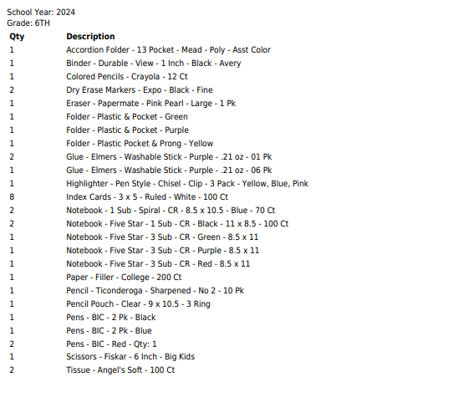

**Grades 6th – 8th**

An accordion file that has at least 5 dividers for folders. A standard messenger bag that does not have dividers is not allowed. Below are some suggested models.

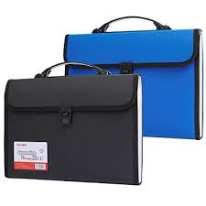

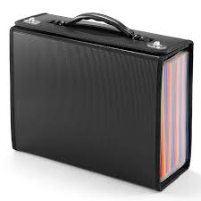

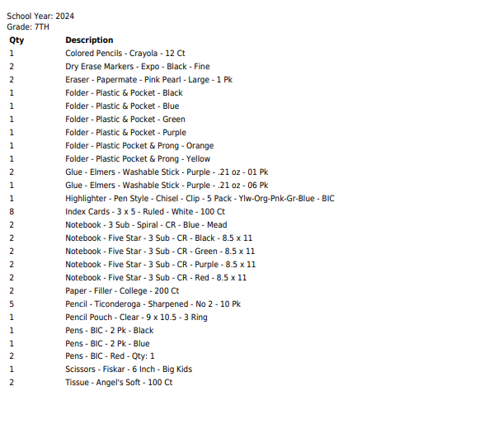

**Grades 6th – 8th**

An accordion file that has at least 5 dividers for folders. A standard messenger bag that does not have dividers is not allowed. Below are some suggested models.





**Grade 7 -** Art sketch book

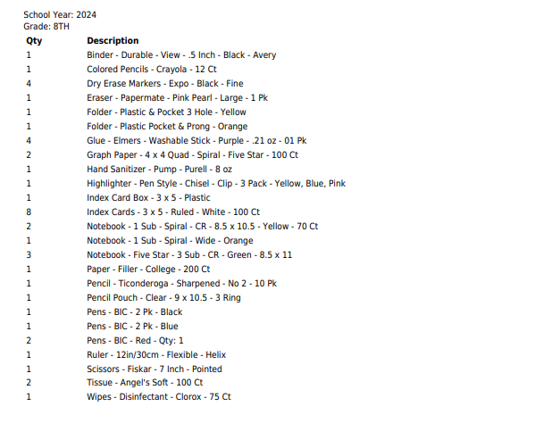

**Grades 6th – 8th** An accordion file that has at least 5 dividers for folders. A standard messenger bag that does not have dividers is not allowed. Below are some suggested models.





**Grades 8th – 11th** (*NOTE: for grade 9 - only for scholars that are taking Algebra 1***)**

TI-84 plus calculator

**Grade 8 -** Art sketch book

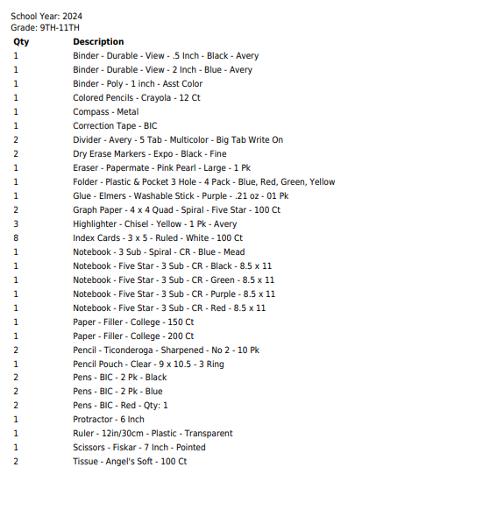

**Grades 8th – 11th** (*NOTE: for grade 9 - only for scholars that are taking Algebra 1***)**

TI-84 plus calculator

**Grade 10 & 11 -** Art sketch book

